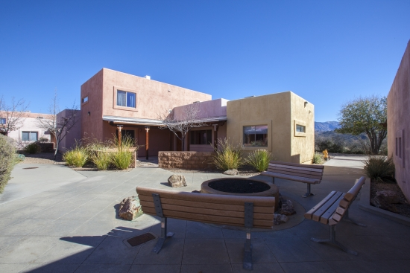

SHARE ON

Biosphere 2's Unique Conference Venue Fosters Creativity, Collaboration in Inspiring Setting
While well-recognized as the place "where science lives," Biosphere 2 is not as well-known for its one-of-a-kind conference and event center. "I've never seen anything like it," says Nirav Merchant, who directs the UA Data Science Institute and has conducted dozens of workshops at the Biosphere 2 Conference and Retreat Center. "I travel to many conferences across the country, and each time a hosting university shows off their conference center, I think to myself, 'You guys should see the one we have at the UA.'"

MORE

